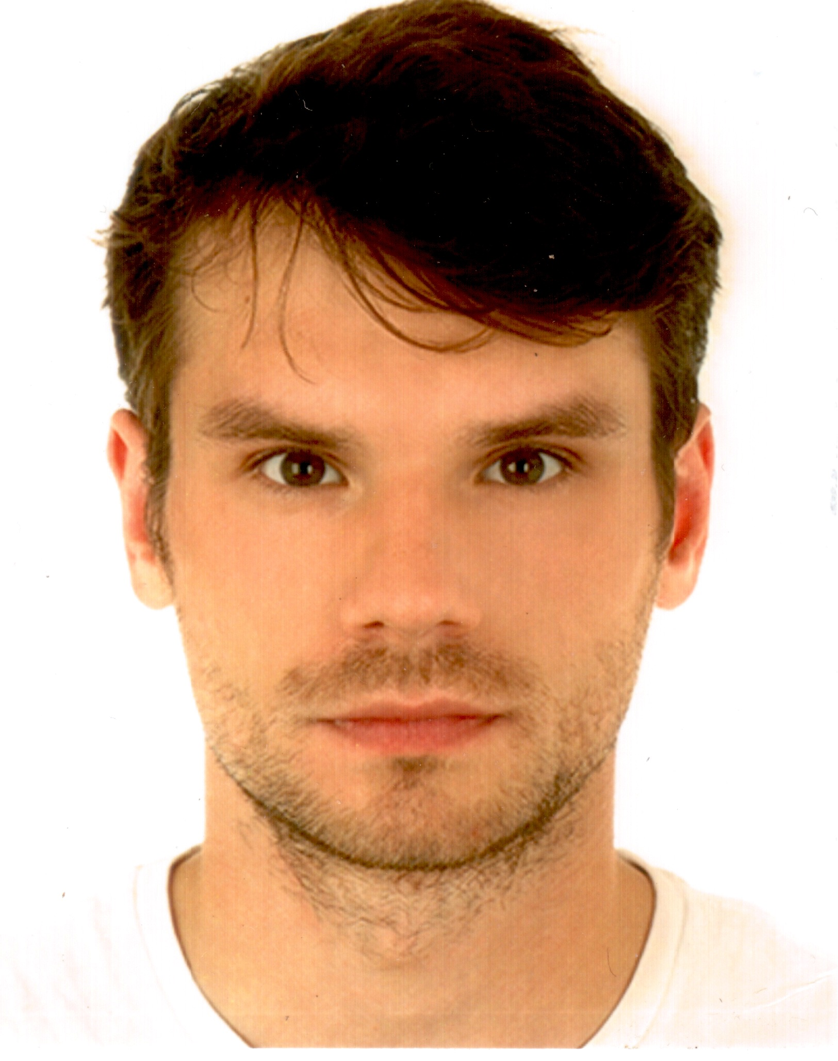
Krzysztof F. Globisz
Tel: +48605949510
krzysztoffglobisz@gmail.com

A film enthusiast since age 4. Graduate from the Polish National Film School in Lodz with a Master’s degree in Cinematography in 2018. Working mostly around Europe on short films, music videos, advertisements and professional feature film/tv series set’s in Poland.

EduCation
The Polish National Film School in Lodz Łódź
Cinematography, master degree 2012-2018
Akademia Multi Art Kraków
Cinematography, Steadicam 2010-2012
Krakowska Akademia Fotografii Kraków
Photography 2009-2010
Jagiellonski University Kraków
Comparative Studies of Civilisation 2009-2012

Film & TV Experience
Lesniczowka (The Ranger’s hut - season 2) prod. TVP 2 2018
camera operator
Slad (The Trace – tv series 48 episodes) prod. Polsat 2018
camera operator
Sprinkle Blizzard – Baguette Soldier (music video) 2018
director of photography
Moonshye - Kamyczki (music video) 2018
director of photography
Adventure Masters. From Here to Oblivio (feature film) dir. Tomasz Szafrański, prod. Dogoda Media 2017
2 unit DP, stills, making off
Downbelow (music video) dir. Robin Lipo 2017
director of photography
Xount’s (advertisement) 2016
camera operator
Tabliczka Mnozenia (short) dir. Youssef Ouarrak 2016
gaffer
Beltaine – Pol(s)ka (music video) dir. Marta Kalfas 2015
director of photography
Toya S.A (advertisement) 2014
director of photography
October (short) dir. Gon Caride 2013
gaffer, grip
Żurek z Kochanowa (documentary) dir. Marta Kalfas 2012
director of photography

SCHOOL PROJECTS 2012-2018
MORSUS, PAN PIOTR, RUSALKA, WILKI W SCIANACH, BLUE VELVET, MGIELKA, SMIERC HARREGO, TEST ADRIANA, TSANTSA
director of photography
Kreacja (short) dir. Katarzyna Latos 2011
director of photography
Nedza (short) dir. Filip Rudnicki 2010
1st AC, stills
Tischner, życie w opowieściach (documentary) dir. Artur Więcek 2008
1st AC, stills

Festival SCreenings
Camerimage Festival, Cannes Short Film Corner, Cracow Film Festival, Filmfest Dresden, Lodzia po Wisle Festival, Dwa Brzegi Festival, Tallgrass Film Festival, Festival de Málaga, Cine en Español, FILMETS Badalona Film Festival

Spoken languages
English – advanced
French - basic
Japanese – basic

